EMMS International
Norton Park, 57 Albion Road, Edinburgh EH7 5QY

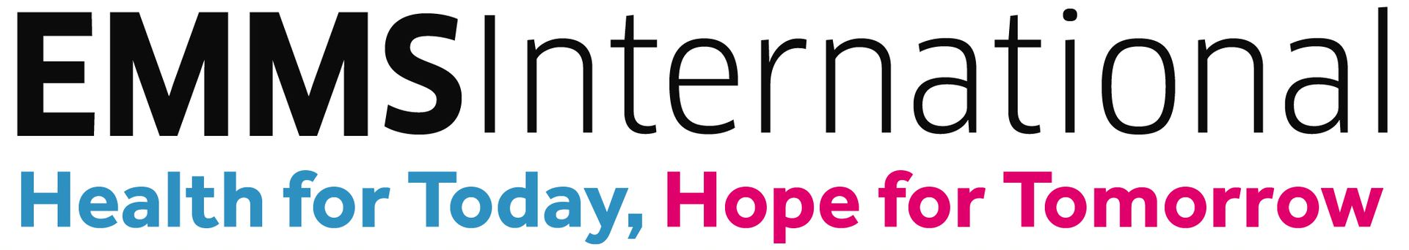

CHILD AND VULNERABLE ADULT PROTECTION POLICY

Child and Vulnerable Adult Protection Officer in 2022 – Laura.Brown@emms.org

EMMS International
Norton Park, 57 Albion Road, Edinburgh, EH7 5QY, Scotland

EMMS International is a registered Scottish Charity No. SC 032327
and a Company Limited by Guarantee No. 224402

TABLE OF CONTENTS
1. Introduction 2
2. Principles 2
3. Child and Vulnerable Adult Protection Code of Conduct 3
4. Child and Vulnerable Adult Protection Procedures 4
4.1 Definition of abuse 4
4.2. Definition of terms in EMMS International’s Child And Vulnerable Adult Protection Policy 5
5. Awareness-Raising 5
6. Prevention Measures 6
7. Reporting 8
8. Responding to Concerns 10
Communication Policy 12
EMMS International Child and Vulnerable Adult Protection Code of Conduct Form 14
EMMS International Self-Disclosure Form 15
EMMS International Child Volunteer Permission Form 17
EMMS International Child Protection Concern Report Form 18
Body Maps 20
BODYMAP 21
Photograph Consent Form 25
Risk Assessment – Out of office promotional activities 26

EMMS International
Norton Park, 57 Albion Road, Edinburgh, EH7 5QY, Scotland

A Company Limited by Guarantee No SC 224402 and registered as a Scottish Charity No SC 032327

1. Introduction

Children and vulnerable adults make up a significant proportion of people served by programmes supported by EMMS International. Through improving healthcare we improve the lives of children and adults who suffer from poverty and inequality and we recognise their particular vulnerability in these contexts. It is essential that everyone that we seek to support is protected from harm and benefits from our programmes in a safe, healthy and relaxed environment. We are committed to the rights of the child in the United Nations Convention on the Rights of the Child (UNCRC) and recognise our responsibility to ensure that those rights are upheld. We do not tolerate any violation or infringement of those rights and strive to ensure that the needs, dignity and safety of all children and adults, regardless of age, sex, pregnancy or maternity, sexual orientation, race, faith, ability, marital or civil partnership status or gender reassignment are protected in our work.

This Policy is for use by EMMS International staff, trustees and volunteers in the UK and on overseas visits. It is a guide for partners and a reference for potential partners, beneficiaries and the public. Its purpose is to provide protection from harm, primarily to children and vulnerable adults, and also to EMMS International staff and volunteers and EMMS International itself. It is guidance to realise our belief that all children, as defined in the UNCRC as anyone under the age of 18, even where defined otherwise in national contexts, and vulnerable adults, must be protected from abuse or exploitation. A vulnerable adult is afforded the same protection as a child. A vulnerable adult is a person aged 18 or over with a condition of the following type:
- a learning or physical disability, or a reduction in physical or mental capacity;
- a physical or mental illness, chronic or otherwise, including addiction to alcohol or drugs;
- poverty; or
- low status, arising from prevailing social norms such as discrimination on grounds of sex.

This policy includes procedures guided by the principles below. It is reviewed every year and the procedures’ implementation is monitored annually. Staff report on incidents relating to protection of children and vulnerable adults to the Safeguarding Committee and the Board of Trustees quarterly. This policy has been approved by the EMMS International Board of Trustees. Concordance with the policy is mandatory for all EMMS International staff, trustees and volunteers and for staff and volunteers of EMMS International’s partner organisations, each of which must have and declare in writing that it implements a policy of similar or greater rigour.

2. Principles
- All children and vulnerable adults have equal rights to development and their welfare is always promoted.
- Children and vulnerable adults are protected from any form of sexual, physical, verbal or emotional abuse or exploitation, from adults and other children.
- The health and safety of children and vulnerable adults is always paramount.
- Children and vulnerable adults are empowered to participate freely in decisions which affect their lives, while recognising the importance of parents, families and other carers.
- Children and vulnerable adults are treated with respect, and valued as individuals and equals with respect to the context of their own culture, religion and ethnicity.
- Children and vulnerable adults are empowered to raise and discuss any concerns and are always listened to.
- Any allegation of abuse is treated seriously and dealt with appropriately and promptly. Victims and other involved parties are supported and perpetrators are held to account.
- Investigation of any Child and Vulnerable Adult Protection concern is conducted with reference to national laws and employment rights and immediately referred to relevant statutory authorities where appropriate.
- Staff and volunteers are recruited, supported and annually trained with respect to the Child and Vulnerable Adults Protection Policy.

3. Child and Vulnerable Adult Protection Code of Conduct
Staff, trustees and volunteers of EMMS International and of its partners must:
- Never hit or physically abuse a child or vulnerable adult in any way;
- Never deliberately place a child or vulnerable adult in danger or at risk of abuse;
- Never have sexual contact or use sexualised language with a child or vulnerable adult;
- Never develop personal relationships with a child or vulnerable adult which could lead to or constitute abuse;
- Never fondle, hold, kiss, hug or touch a child or vulnerable adult inappropriately;
- Never intentionally behave in a way to frighten or intimidate a child or vulnerable adult;
- Never purchase sex or condone prostitution while travelling for EMMS International;
- Never do personal things for a child or vulnerable adult that they can do themselves;
- Never single out a child or vulnerable adult for special treatment;
- Never give a child or vulnerable adult presents or personal items unless authorised by the Child and Vulnerable Adult Protection Officer;
- Never invite a child or vulnerable adult into their home or arrange to see them outside project activities unless authorised by the Child and Vulnerable Adult Protection Officer;
- Always endeavour not to stay alone overnight with a child, children or vulnerable adult;
- Never take a child or vulnerable adult in their car, except in exceptional circumstances;
- Never hire a child or vulnerable adult for any service, or treat in any exploitative way;
- Never use internet resources such as social networking sites to make inappropriate contact with children or vulnerable adults which could lead to or constitute abuse;
- Never use racist, sexist, discriminatory, inappropriate, abusive or offensive language around children or vulnerable adults;
- Never intentionally humiliate or degrade children or vulnerable adults;
- Never smoke, use illegal drugs, consume or be under the influence of alcohol in the presence of children or vulnerable adults;
- Always treat children and vulnerable adults with respect;
- Always listen to children and vulnerable adults and their concerns;
- Always use sensitive language when a child or vulnerable adult reveals a serious issue (such as child abuse or sexual violence) (see section 7.3 for further details);
- Always be accompanied by another adult if in the company of a child or vulnerable adult;
- Always deal with any allegations or concerns relating to abuse immediately and appropriately in accordance with the Child and Vulnerable Adult Protection Procedures;
- Always be aware of the health and safety of children and vulnerable adults and ensure their protection from harm when they are in care of EMMS International or its partners;
- Always respect the rights of children and vulnerable adults and empower them to be aware of and act upon their rights;
- Always challenge the mistreatment of children and vulnerable adults and report any cases of abuse in accordance with the section of this policy on Reporting;
- Always ensure that images of children and vulnerable adults are respectful, and obtain permission from a child, vulnerable adult and/or their parent/guardian or carer before using their image. This applies to images taken in the UK or other countries.

4. Child and Vulnerable Adult Protection Procedures

4.1 Definition of abuse
Scottish Government 2014 National Guidance for Child Protection in Scotland gives these definitions: “Abuse and neglect are forms of maltreatment of a child. Somebody may abuse or neglect a child by inflicting, or by failing to act to prevent, significant harm to the child. Children may be abused in a family or in an institutional setting, by those known to them or, more rarely, by a stranger… The following definitions show some of the ways in which abuse may be experienced by a child but are not exhaustive, as the individual circumstances of abuse will vary from child to child.
Physical Abuse | … Physical abuse may involve hitting, shaking, throwing, poisoning, burning or scalding, drowning or suffocating. Physical harm may also be caused when a parent or carer feigns the symptoms of, or deliberately causes, ill health to a child they are looking after. For further information, see the [Scottish Government’s] section on Fabricated or induced illness [following the link in the footnote to this section].
Emotional Abuse | Emotional abuse is persistent emotional neglect or ill treatment that has severe and persistent adverse effects on a child’s emotional development. It may involve conveying to a child that they are worthless or unloved, inadequate or valued only insofar as they meet the needs of another person. It may involve the imposition of age- or developmentally-inappropriate expectations on a child. It may involve causing children to feel frightened or in danger, or exploiting or corrupting children. Some level of emotional abuse is present in all types of ill treatment of a child; it can occur independently of the other forms of abuse.
Sexual Abuse | Sexual abuse is any act that involves the child in any activity for the sexual gratification of another person, whether or not it is claimed that the child either consented or assented. Sexual abuse involves forcing or enticing a child to take part in sexual activities, whether or not the child is aware of what is happening. The activities may involve physical contact, including penetrative or non-penetrative acts. They may include non-contact activities, such as involving children in looking at, or in the production of, indecent images or in watching sexual activities, using sexual language towards a child or encouraging children to behave in sexually inappropriate ways (see also [Scottish Government] section on child sexual exploitation).
Neglect | Neglect is the persistent failure to meet a child’s basic physical and/or psychological needs, likely to result in the serious impairment of the child’s health or development. It may involve a parent or carer failing to provide adequate food, shelter and clothing, to protect a child from physical harm or danger, or to ensure access to appropriate medical care or treatment. It may also include neglect of, or failure to respond to, a child’s basic emotional needs. Neglect may also result in the child being diagnosed as suffering from ‘non-organic failure to thrive’, where they have significantly failed to reach normal weight and growth or development milestones and where physical and genetic reasons have been medically eliminated. In its extreme form children can be at serious risk from the effects of malnutrition, lack of nurturing and stimulation. This can lead to serious long-term effects such as greater susceptibility to serious childhood illnesses and reduction in potential stature. With young children in particular, the consequences may be life-threatening within a relatively short period of time”

For EMMS, the above principles also apply to the protection of vulnerable adults.

4.2. Definition of terms in EMMS International’s Child And Vulnerable Adult Protection Policy
Term | Definition | Example
UK staff and/or trustees | EMMS International staff and trustees based in the UK. | Staff working in the EMMS International office in Edinburgh.
Overseas consultants | People contracted in project countries doing work for EMMS International. | Evaluation and Finance consultants in Malawi, India or Nepal.
Volunteer | A volunteer who works for EMMS International in the UK or another country. | A volunteer who helps raise funds or gives talks in the UK.
EMMS International manager | A member of staff responsible for managing other members of staff and/or an EMMS International budget, in any country. | Director of International Programmes.
EMMS International supervisor | A member of staff responsible for managing a designated volunteer, in any country. | Fundraising volunteers managed by a member of Fundraising staff.
Partners | Organisations which implement projects for which they receive funding from EMMS International. | Hospitals which deliver healthcare in Malawi, Nepal or India.
Partner staff and volunteers | The staff and volunteers of partners, whether in the UK or other countries. | Project coordinators who help deliver projects or provide healthcare in India, Malawi or Nepal.
Child and Vulnerable Adult Protection Officer  (Lead CVAPO) | A designated member of EMMS International staff who has responsibility for child and vulnerable adult protection, both in the UK and other countries. The CVAPO will monitor the charity’s work on child and vulnerable adult protection and provide guidance to the Child and Vulnerable Adult Protection Committee if necessary. | EMMS International Director of Fundraising
Safeguarding Committee | A group of EMMS International staff members and at least one board member who meet to review child and vulnerable adult protection issues quarterly. | EMMS board member, Director of International Programmes and Director of Fundraising

5. Awareness-Raising

5.1 EMMS International’s Child and Vulnerable Adult Protection Policy is freely available to the general public and to all EMMS International staff, trustees, volunteers, partners and partners’ clients. The Child and Vulnerable Adult Protection Policy is available on the EMMS International website and is regularly referenced in appropriate documents.

5.2 All new and existing EMMS International staff are required to participate in annual training on EMMS International’s Child and Vulnerable Adult Protection Policy and are updated annually on child and vulnerable adult protection issues by the Safeguarding Committee, both activities led by the Child and Vulnerable Adult Protection Officer.

5.3 All new and existing volunteers in the UK and other countries, whose role involves contact with children and vulnerable adults are required to participate in training on EMMS International’s Child and Vulnerable Adult Protection Policy and are updated on the issues by their EMMS staff supervisor, supported by the Child and Vulnerable Adult Protection Officer.

5.4 All EMMS International managers are responsible for ensuring that their staff have participated in training on child and vulnerable adult protection and understand the Child and Vulnerable Adult Protection Policy and its implications.

5.5 All new and existing EMMS International staff in posts which have or may have regular contact with children and/or vulnerable adults, and the Child and Vulnerable Adult Protection Officer, are required to attend specialised training on child and vulnerable adult protection and may be required to attend further courses on this as necessary.

5.6 All new and existing staff, trustees and volunteers are required to follow the EMMS International Child and Vulnerable Adult Protection Code of Conduct and have signed a copy of this, which is kept on file. Refusing to sign may result in disciplinary action for staff and the termination of a relationship with volunteers.

5.7 EMMS International engages with partners on child and vulnerable adult protection, explaining our commitments and requiring partners to have and declare in writing that they implement child and vulnerable adult protection policies and procedures relevant to their local context and compatible with the United Nations Convention on the Rights of the Child. EMMS International encourages partners to use this EMMS International policy as their model.

5.8 EMMS International staff must always check against this policy when organising any EMMS International event or visit.

6. Prevention Measures

Staff and Volunteer Recruitment
6.1 EMMS International ensures that its employment and recruitment procedures and practices comply with local laws and refer to Keeping Children Safe standards and recommendations.

6.2 Recruitment of internal and external candidates for posts which have or could have contact with children and vulnerable adults, including all posts involving travel outside the UK, must include:
- specifying in adverts and job descriptions that posts are disclosure-accepted posts for the Rehabilitation of Offenders Act 1974;
- reference to EMMS International’s commitment to child and vulnerable adult protection and the Child and Vulnerable Adult Protection Policy in adverts and job descriptions;
- questions to candidates in interviews on their previous experience of working with children, young people or vulnerable adults, and this specific question: “Have you ever been involved in crime or been part of a safeguarding problem?”;
- ensuring that candidates can provide two referees who can comment on their work with children, young people or vulnerable adults;
- ensuring that appointed candidates complete the appropriate disclosure process below;
- verifying the identity of candidates appointed to posts which will or may have regular contact with children or vulnerable adults.
6.3 Job offers for posts with regular contact with children and vulnerable adults, including all posts involving travel outside the UK, are subject to a Disclosure Process which will include Basic Disclosure through the EMMS International Disclosures Administrator, or the relevant local checks through the relevant national government agencies where possible. Satisfactory verification of qualifications and work history are also required.

6.4 Any volunteers recruited or designated for work with children and/or vulnerable adults are asked to complete Basic Disclosure through the EMMS International Disclosures Administrator, provide two suitable referees and, where appropriate, complete an Enhanced Disclosure, or the relevant local checks through the relevant national government agencies where possible.

6.5 All staff and trustees must undergo Basic Disclosure through the EMMS International Disclosures Administrator every 3 years.

EMMS International schools’ and children’s groups
6.6 EMMS International staff and volunteers always ensure that another responsible adult is present when working with children. EMMS International staff and volunteers always minimise the likelihood of situations occurring in which they are lone adults working with one or more children.

6.7 EMMS International partners involved in meetings with children during visits to the UK are always briefed on EMMS International’s Child and Vulnerable Adult Protection Policy, and are asked to sign the Child Protection Code of Conduct. A member of EMMS International staff or a volunteer is present in any such work involving children or vulnerable adults.

Children and vulnerable adults working as Volunteers
6.8 All children and vulnerable adults are supervised by their legal guardian or a responsible adult nominated by their legal guardian whilst undertaking voluntary work for EMMS International. Adults do not supervise more than six children each.

6.9 EMMS International staff or volunteers working with groups of children, such as school or scout groups who are volunteering for EMMS International, ensure that school or relevant group leaders have obtained the necessary permission from parents or guardians. Responsibility for these children remains with the school or group.

6.10 EMMS International supervisors ensure that children who are volunteering as individuals have provided a completed Child Volunteer Permission Form. A new form is completed on every occasion, unless the volunteer works with EMMS International more than once a month, in which case the Form is kept on file and renewed on an annual basis.

Out of office promotional activities
6.11 EMMS International and its partners assess risk of all promotional activities using the form Risk Assessment of Our of Office Promotional Activities which is an annex to this policy.

Communications and Media
6.12 EMMS International ensures that the welfare of children and vulnerable adults is paramount and that their interests and safety always take priority over any editorial requirement.

6.13 The impact and possible consequences of any material which involves a child or vulnerable adult is carefully considered, both before and after publication or broadcast. The risks that children and vulnerable adults may face through their involvement in EMMS International communications are continuously monitored and staff consider these on a case by case basis.

6.14 EMMS International endeavours to ensure that images and/or stories about children and vulnerable adults cannot be misused or exploited.

6.15 Communications about children and vulnerable adults always respect the individual’s dignity and identity, and are not degrading. EMMS International always tries to ensure that children and vulnerable adults are portrayed as realistically as possible and that language that implies any relationship of power is avoided.

6.16 Any material featuring in EMMS International publications and website must be suitable for a general audience, including children.

6.17 EMMS International staff and volunteers, whether in the UK or other countries, always:
- seek the consent of parents or legal guardians, or other person in loco parentis (e.g. teacher), and of the vulnerable adult themselves, before interviewing a child or vulnerable adult, or taking film, photograph or sound recordings in which they appear; where practical, permission should be in writing;
- seek consent of parents, legal guardians or other person in loco parentis, or of the vulnerable adult, before publishing any material including a child or vulnerable adult;
- seek the consent of a child or vulnerable adult for their participation, and respect any refusal to take part;
- give no money to a child, vulnerable adult, parent or guardian to gain consent;
- obtain permission from the headteacher for any filming or interviewing on school premises during school hours;
- approach the gathering of material sensitively and consider the impact that recounting experiences may have on a child or vulnerable adult;
- take steps to minimise any distress that may be caused by taking part in an interview;
- provide extra protection to certain children and vulnerable adults who need it (e.g. political refugees or those suffering from disease);
- conceal the identity and location of children and vulnerable adults (for example withholding or changing names);
- take additional steps to establish any potential risks where it is not possible to obtain individual permissions (for example in large group shots taken from a distance) and conceal the identity and location of children and vulnerable adults to mitigate any risks;
- endeavour to use images in which children and adults are adequately clothed, by the commonly accepted standards of UK viewers;
- consider the messages that are being communicated about children and vulnerable adults and ensure that these are fair and avoid stereotype or discrimination.
6.18 Where there is any doubt on the use of images and/or stories, EMMS International staff and volunteers seek the guidance of their Child and Vulnerable Adult Protection Officer.

EMMS International Partners
6.19 EMMS International Project Agreements specify that all partners must have child and vulnerable adult protection measures and should implement their own child and vulnerable protection policy, while agreeing to abide by EMMS International’s Policy and Code of Conduct.

7. Reporting
7.1 EMMS International staff and volunteers have a duty to ensure that the EMMS International code of conduct is adhered to throughout the organisation.

7.2 A Child Protection Concern Report form is available to all EMMS International staff and volunteers.

7.3 EMMS International staff and volunteers should respond sensitively to any Child Protection issue that they witness or is disclosed to them and treat the issue confidentially. If a child or vulnerable adult discloses that they are being abused, or if anybody reports that someone else is being abused, EMMS International staff and volunteers should:
- stay calm, listen carefully and take the allegation seriously,
- not promise to keep it secret but explain that they need to tell someone else,
- stress that the individual was right to tell them, that they have taken it seriously and that they have understood what they have been told,
- only ask questions for clarity and not ask for explicit details,
- reassure the person that they will take steps to help and tell them what will happen next.
7.4 EMMS International staff and volunteers should be confident that the disclosure of any serious allegation will not affect their position or reputation within EMMS International.

7.5 Any EMMS International staff member who witnesses or is informed of any potential breach of the Child Protection Code of Conduct must complete the Child Protection Concern Report Form and inform their line manager, other available senior member of staff and the Child and Vulnerable Adult Protection Officer of the concern immediately. This policy states the email address of the Child and Vulnerable Adult Protection Officer on the title page. Email addresses of other staff are in the Whistleblowing Policy. If anybody reports to any staff member a situation or a case as described in 4.1 above (Definition of abuse), that staff member must inform their line manager, other available senior staff and the Child and Vulnerable Adult Protection Officer immediately.

7.6 Any volunteer who witnesses or is informed of any potential breach of the Child Protection Code of Conduct must complete the Child Protection Concern Report Form and inform their designated EMMS International supervisor of the concern immediately.

7.7 EMMS International managers, supervisors or volunteer coordinator must inform the Child and Vulnerable Adult Protection Officer of any allegation or concern immediately. If for any reason this is not possible, staff must ensure that the matter is referred to an appropriate senior member of staff so that the concern can be managed with the necessary urgency.

7.8 The Child and Vulnerable Adult Protection Officer is responsible for the management of the investigation of any concern. Staff and volunteers should not seek to conduct their own investigation or discuss the issue with any other party such as volunteers or external parties.

7.9 The Child and Vulnerable Adult Protection Officer ensures that all records of any breach of the code of conduct are full and detailed, treated confidentially and stored securely.

7.10 EMMS International’s Safeguarding Committee’s duties include completing quarterly the EMMS International Safeguarding Register and submitting this completed register plus the committee’s quarterly minutes to the EMMS International board as board papers. All EMMS International partners must complete and email to EMMS quarterly the Safeguarding Register using EMMS International’s format.

EMMS International Partners
7.10 Partners must inform EMMS International of any child and vulnerable adult protection concerns that occur in EMMS International-funded projects or in their organisation immediately.

7.11 Any child and vulnerable adult protection concern relating to partners which is raised by staff, volunteers or members of the public must be recorded and raised with the Child and Vulnerable Adult Protection Officer and senior staff who will manage any response to this.

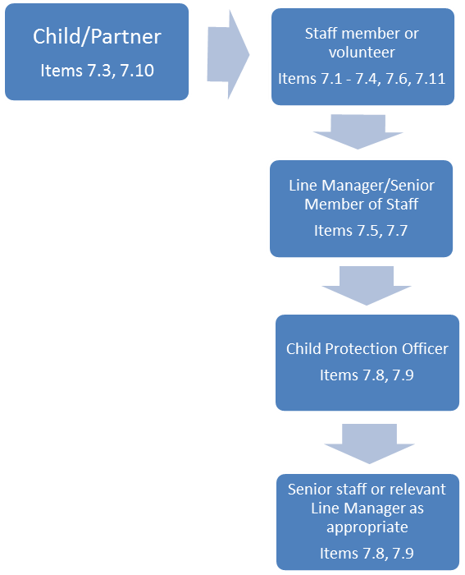
EMMS Fiduciary Duty
7.12 If the incident reported is of sufficient concern, it should be reported to the Office of the Scottish Charity Regulator (OSCR) as a Notifiable Event. Staff and trustees should refer to the OSCR website to understand whether the case in question is a Notifiable Event.

8. Responding to Concerns

EMMS International staff and volunteers
8.1 The Child and Vulnerable Adult Protection Officer (CVAPO) is responsible for ensuring that a thorough investigation of any concern is conducted, either by the CVAPO or by an appropriate member of staff, immediately, where there has been a breach of the Code of Conduct by a member of staff or volunteer. The CVAPO should always refer any reported concern to the EMMS International Leadership Team, who may decide to report this to the Board of Trustees.

8.2 In some instances it may also be necessary for the CVAPO to ensure that the concern is immediately referred to the relevant statutory authorities (i.e. Police or Child Welfare Authority) to ensure that the child or vulnerable adult is protected from any further harm, or to report a crime. In these instances the CVAPO should always refer any reported concern to the EMMS International Leadership Team who will report this immediately to the Board of Trustees.

8.3 It may be necessary for a member of staff to be suspended whilst an investigation is taking place. Any suspension will be as brief as possible and on full pay. Any action taken will be in line with the EMMS International Disciplinary, Appeal and Grievance Procedure.

8.4 It may be necessary for a volunteer to be suspended while an investigation is taking place. Any suspension will be as brief as possible.

8.5 EMMS International will endeavour to ensure that any child, vulnerable adult or other party who has been affected by any breach of the code of conduct is given immediate and appropriate support and care and that steps are taken to ensure that the child or vulnerable adult will receive appropriate long-term support where necessary.

8.6 EMMS International will endeavour to ensure that any member of EMMS International staff or volunteer who has been suspended while an investigation is taking place is given appropriate support. Suspension during an investigation does not constitute disciplinary action or imply guilt and if no breach has taken place, records of any investigation will be destroyed within one year of the investigation.

8.7 The CVAPO is responsible for ensuring that a full investigation report is produced, which will be reviewed by the appropriate line manager and senior staff members. Any investigation will always be conducted with reference to national laws and employment rights and where any concern could constitute a criminal act the details will be immediately referred to any relevant statutory authorities.

8.8 Following full investigation, EMMS International may implement the relevant disciplinary action for staff in accordance with EMMS International’s Disciplinary Procedure. Staff have the right to respond to this as appropriate, in accordance with the EMMS International staff handbook.

8.9 Where a concern relates to any volunteer, EMMS International may end the volunteer relationship.

EMMS International partners
8.10 Partners must report the outcome of any internal investigation regarding a Child and Vulnerable Adult Protection concern to EMMS International immediately. EMMS International expects partners to ensure that appropriate actions are taken in relation to any concern and to report the action taken to EMMS International. In cases where EMMS International judges that sufficient actions have not been taken, EMMS International may end a partner relationship.

Additional Documents
- Communication Policy
- EMMS International Child and Vulnerable Adult Code of Conduct Form
- Child and Vulnerable Adult Protection Self-Disclosure Form
- Child Volunteer Permission Form
- Child and Vulnerable Adult Protection Concern Report Form
- Body Maps
- Photograph Consent Form
- EMMS International quarterly Safeguarding Register (a separate, Excel document)

Communication Policy

1. Introduction
We live in a world where images of children and vulnerable adults are very often exploited and we recognise that children are particularly vulnerable to trafficking and abuse. EMMS International is committed to the protection of children and vulnerable adults as a fundamental principle, through programme implementation, recruitment of employees and volunteers, and communications.

This document sets out EMMS International’s policy and practice in the gathering and publication of images, video footage and text referring to children and vulnerable adults, and is one of a set of documents governing the Child and Vulnerable Adult Protection Policy.

The practice described is intended to ensure that the rights of children and vulnerable adults are respected, while allowing EMMS International to report on the work of its partners using stories and images, both still and moving.

2. Use of images and Stories
- EMMS International’s communications about children and vulnerable adults must respect the individual’s dignity and identity.
- We strive to:
  - Portray children and vulnerable adults as realistically as possible, in their own context, without being overly sensational or overly positive, and without portraying children and vulnerable adults as victims;
  - Represent different types of children and vulnerable adults in the areas where our partners work and portray the perspectives of children and vulnerable adults;
  - Be aware that some children and vulnerable adults need extra protection when their stories are told, for example, those who have been orphaned by AIDS or who are living with HIV/AIDS;
  - Ensure that children and vulnerable adults and their legal guardians are fully informed of any possible risks and made aware of their rights so that they can make informed decisions about sharing their story;
  - Ensure participants understand how their story will be used in EMMS International materials;
  - Ensure participants see how their story is used in EMMS International materials – this may be after an appeal and after the work funded through this appeal has started;
  - Empower children and vulnerable adults through telling their story.

3. Consent
Wherever possible, as well as gaining consent from the child or vulnerable adult, EMMS International will acquire verbal or written consent from the parent, carer, child’s school, whoever is acting in loco parentis (e.g. the partner organisation responsible for the child or vulnerable adult) or the vulnerable adult themselves, to use images and stories for external communication. This may not always be possible when dealing with crowd shots.

No payment or reward shall be given to gain consent. There must be no payment to minors for information involving the welfare of children or vulnerable adults, or payment to parents, guardians or carers (including schools and partners) for information about children or wards.

It will be made clear to all, including children, vulnerable adults, parents (and those in loco parentis), carers, guardians and vulnerable adults, that receiving support from an EMMS International partner does not oblige them to participate in our communications.

When photographing or filming in schools, it is good practice to give the school sufficient advance notice so that they can contact children’s parents to gain consent.
Even if informed consent has been received, EMMS International may decide not to publish a story if it is regarded as damaging to the child’s interest.

4. Confidentiality
While it is extremely important to publish real stories and photographs for the sake of authenticity and transparency, EMMS International will strive to protect the identity of children and vulnerable adults in order to:
1. Avoid the exploitation of images and stories by those who may wish to misuse them; and
2. Protect children and vulnerable adults from being stigmatised or mistreated in their own communities as a result of any publication arising from the interview or subsequent publication of photographs or images.

For the above reasons, EMMS International will not use the name or family name, or name of school of a child or vulnerable adult, in external communications and/or reports to donors.

Sensitive Cases
Identities should be further protected where children and vulnerable adults have particularly sensitive stories to tell, such as:
- Sexual abuse
- Sexual activity
- Pregnancy
- Domestic violence
- Pending or current court cases
- Child labour
- Living with HIV/AIDS
- Fostered girls and boys
- Prostitution
- Other economic or political factors that threaten the child’s or vulnerable adult’s safety.

Identities shall be protected by using a pseudonym, to protect a child’s or vulnerable adult’s identity, and be footnoted in the text with the following:
“Names have been changed in order to protect the identities of those involved.”
Care will be taken to note the name change for future use of the same story and photographs.

Exceptions:
Exception to the above can be made when the audience for a particular communication is limited and known by EMMS International (e.g. a letter to major donors or report to a funding agency).
Family and school names may be used for transparency to illustrate non-sensitive stories.

5. Interviewing Children and Vulnerable Adults
All interviews with children and vulnerable adults should be conducted with extra care for the welfare and safety of the individual. The cultural values, interests and priorities of the individual should be honoured, and child-friendly language should be used. Information should be shared with the interviewee in a transparent way.

Questions that are overly intrusive or sensationalised are not allowed.

Children and vulnerable adults should not be interrogated about private family matters nor asked expressions of opinion on matters likely to be beyond their judgement.

The EMMS International Child and Vulnerable Adult Protection Policy shall be adhered to at all times when interviewing and photographing or filming a child or vulnerable adult.

EMMS International Child and Vulnerable Adult Protection Code of Conduct Form

I agree to abide by the following code of conduct and to:
- Never hit or physically abuse a child or vulnerable adult in any way;
- Never deliberately place a child or vulnerable adult in danger or at risk of abuse;
- Never have sexual contact or use sexualised language with a child or vulnerable adult;
- Never develop a personal relationship with a child or vulnerable adult which could lead to, or constitute, abuse;
- Never fondle, hold, kiss, hug or touch a child or vulnerable adult inappropriately;
- Never intentionally behave in a way that frightens or intimidates a child or vulnerable adult;
- Never purchase sex or otherwise condone prostitution while travelling for EMMS International;
- Never do things of a personal nature for a child or vulnerable adult that they can do for themselves;
- Never single out a child or vulnerable adult for special treatment;
- Never give a child or vulnerable adult presents or personal items unless authorised by the Child and Vulnerable Adult Protection Officer;
- Never invite a child or vulnerable adult into my home or arrange to see them outside project activities unless authorised by the Child and Vulnerable Adult Protection Officer;
- Never stay alone overnight with a child or children or any vulnerable adult;
- Never take a child or vulnerable adult with me in my car, except in exceptional circumstances;
- Never hire a child or vulnerable adult for any service or treat a child or vulnerable adult in any way which could be deemed exploitative;
- Never use internet resources such as social networking sites to make inappropriate contact with children or vulnerable adults which could lead to or constitute abuse;
- Never use racist, sexist, discriminatory, inappropriate, abusive or offensive language around children or vulnerable adults;
- Never intentionally humiliate or degrade children or vulnerable adults;
- Never smoke, use illegal drugs, consume or be under the influence of alcohol in the presence of a child or vulnerable adult;
- Always treat children and vulnerable adults with respect;
- Always listen to children and vulnerable adults and their concerns;
- Always use sensitive language when a child or vulnerable adult reveals a serious issue (such as abuse or sexual violence);
- Always endeavour to be accompanied by another adult when in the presence of a child, children, vulnerable adult or vulnerable adults;
- Always deal with any allegations or concerns relating to abuse immediately and appropriately, in accordance with the Child and Vulnerable Adult Protection Procedures;
- Always be aware of the health and safety of children and vulnerable adults and ensure that they are protected from harm when they are in the care of EMMS International;
- Always respect the rights of children and vulnerable adults and empower them to be aware of and act upon their rights;
- Always challenge the mistreatment of children and vulnerable adults and report any cases of abuse;
- Always ensure that images of children and vulnerable adults are respectful, and obtain permission from a child, vulnerable adult and/or their parent/guardian or carer before using their image.

Name:_______________________________________ Date:______________

Signature:__________________________________ Date:______________

EMMS International Self-Disclosure Form

All staff and trustees of EMMS International must undergo Basic Disclosure through the EMMS International Disclosures Administrator. In addition, any member of EMMS International staff or volunteer being recruited by EMMS International, whose work will involve contact with children and vulnerable adults, is required to disclose all relevant charges and convictions directly to EMMS International in this form.

If you are provisionally offered employment or voluntary opportunities for a post which will involve work with children and/or vulnerable adults, we may seek an Enhanced Disclosure from the relevant authority. This type of disclosure will include any non-conviction information considered relevant by the Chief Constable or the relevant authority.

EMMS International is committed to equality, meaning we will be fair in our recruitment process. A conviction will not necessarily be a barrier to working with us and any information you provide will be treated in the strictest confidence.
Please complete the following information, which is aimed at helping us establish your suitability for this post and verifying the authenticity of your application:

Surname:
Forenames:
Previous Surnames:
Date of Birth:
Female/Male:
Position Applied for:

Please give your current address

Do you have any previous convictions, cautions, reprimands or final warnings? | Yes/No
If Yes, please give details (continue on a separate sheet if necessary):

Are you subject to any pending prosecutions? | Yes/No
If Yes, please give details (continue on a separate sheet if necessary):

Are you subject to any pending disciplinary action, complaints or investigations relating to children and/or young people or vulnerable adults in your current employment? | Yes/No
If yes, please give details (continue on a separate sheet if necessary):

Has a previous employer ever taken disciplinary action against you or dismissed you in relation to incidents involving children and/or young people or vulnerable adults? | Yes/No
If yes, please give details (continue on a separate sheet if necessary):

Has any child or vulnerable adult that you have ever been responsible for been placed on a child protection register or been the subject of a court order? | Yes/No
If yes, please give details (continue on a separate sheet if necessary):

Declaration
By signing and returning this form, I consent to EMMS International obtaining, keeping, using and producing information relating to my application in line with the requirements of the Data Protection Act 1998.

I understand that this form will be kept for the duration of the recruitment activity, after which it will be destroyed. However, if I am appointed, any information that may have a bearing on my future employment with EMMS International will be kept in a sealed envelope until any convictions declared are spent or until 6 years following the termination of my employment with EMMS International, whichever is sooner.

I am committed to EMMS International’s aim to ensure that the charity’s work with children and vulnerable adults promotes their health, welfare and development and recognise my duty to ensure that children and vulnerable adults are kept safe from harm whilst in the charity’s care. I understand that to give false information or to omit information knowingly will be considered a breach of trust and could result in disqualification from the selection process or my dismissal at any time. I understand that if I am subsequently convicted of any criminal offence, I must declare this to EMMS International. I declare that the information I have given on this form is true and complete and that I am aware of no reason why I would be considered unsuitable to work with children or vulnerable adults.
Signed: | Date:

EMMS International Child Volunteer Permission Form
Volunteer Name:
Address:
Date of Birth:
Relevant medical conditions:
Name of Parent/Guardian:
Relationship to volunteer:
Address if different from above:
Emergency contacts:  Please provide two, one must be person signing the form | Name:  Relationship to volunteer:  Tel:
Name:
Relationship to volunteer:
Tel:

I agree that _______ can volunteer for EMMS International:

Signed: Date:__________

EMMS International Child Protection Concern Report Form

This form is to record safeguarding concerns relating to children or vulnerable adults. In an emergency, do not delay in informing the police or other authority. All information must be treated as confidential and reported to EMMS International’s Child and Vulnerable Adult Protection Officer within 1 working day. This form must be completed at the time or immediately following disclosure, after all necessary emergency actions have been taken.
A copy of this form must be retained by the person reporting the concern.

Details of person completing the form
Name
Address
Role within/relationship to EMMS International
Relationship to child or vulnerable adult

Details of child or vulnerable adult and guardian
Name
Address
Female/Male
Age
Name of parent/guardian
Address of parent/guardian
Phone number of parent/guardian

Details of concern
How did you come to have a concern:
- Was abuse observed or suspected?
- Was an allegation made?
- Did a child or vulnerable adult disclose abuse?
Nature of concern/allegation
Date, time and place of any incident(s)
Observations made by you (e.g. physical signs observed, individual's behaviour)
What the child or vulnerable adult told you and what you said:
(Continue on a separate sheet if necessary)
Where the child or vulnerable adult is now and who is looking after them
Are there any immediate health or protection issues for the child or vulnerable adult? (E.g. do they need to be removed from the situation)
Were any other children or vulnerable adults involved or aware?
Any other relevant information?
Have you reported this concern/allegation to parents, carers or any authorities? If so please provide details of this. (name, address, relationship to child or vulnerable adult)
Advice given
Action taken/status of any actions taken
Where can additional information regarding incident be found (e.g. incident book, staff file, patient records)?
Time and date of reporting
Signed

Body Maps

Body Maps should be used to document and illustrate visible signs of harm and physical injuries.

Always use a black pen (never a pencil) and do not use correction fluid or any other eraser.

Do not remove clothing for the examination unless the injury site is freely available because of treatment.
At no time should an individual or member of staff take photographic evidence of any injuries or marks on a person. The body map below should be used. Any concerns should be reported and recorded without delay to the appropriate safeguarding services, e.g. Social Care direct or child’s social worker if already an open case to social care.

When you notice an injury to an individual, try to record the following information of each mark identified e.g. red areas, swelling, bruising, cuts, lacerations, wounds, scalds and burns:

- Exact site of injury on the body, e.g. upper outer arm/left cheek.
- Size of injury - in appropriate centimetres or inches.
- Approximate shape of injury, e.g. round/square or straight line.
- Colour of injury - if more than one colour, say so.
- Is the skin broken?
- Is there any swelling at the site of the injury, or elsewhere?
- Is there a scab, any blistering or any bleeding?
- Is the injury clean or is there grit or fluff or similar?
- Is mobility restricted as a result of the injury?
- Does the site of the injury feel hot?
- Does the individual feel hot?
- Does the individual feel pain?
- Has the individual’s body shape changed/are they holding themselves differently?

The date and time of the recording must be stated as well as the name and designation of the person making the record. Add any further comments as required.

Ensure First Aid is provided where required and record

A copy of the body map should be kept on the individual’s confidential file. Please see the body map in the next pages.

BODYMAP
(This must be completed at time of observation)

Name of Individual: |  |  |  | Date of Birth:
Name of Staff: |  |  |  | Job title:
Date and time of observation:
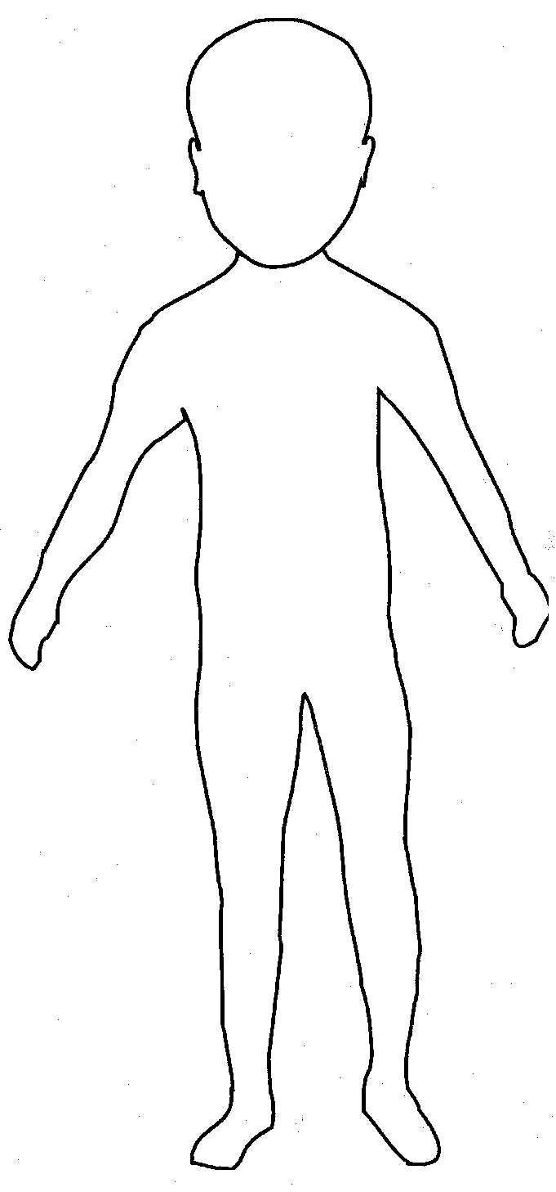 |  |  | 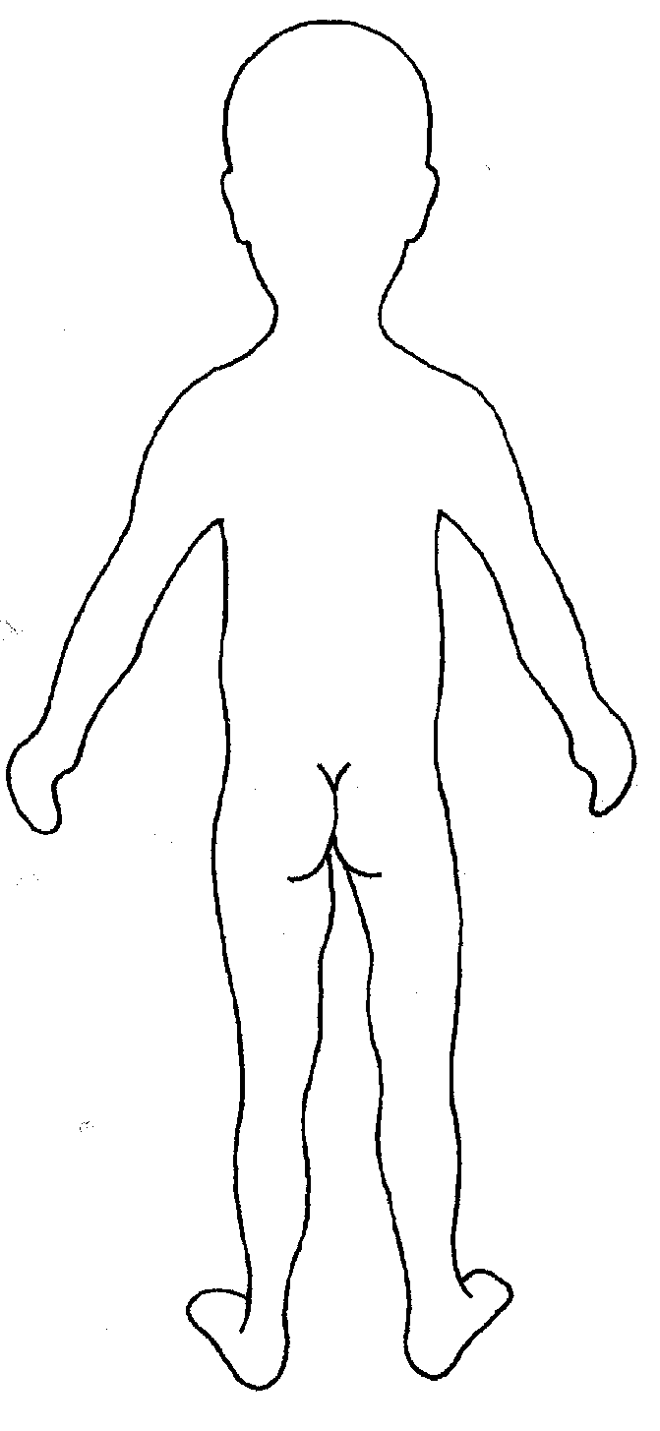

Name of individual: |  |  |  |  |  |  |  |  | Date and time of observation:
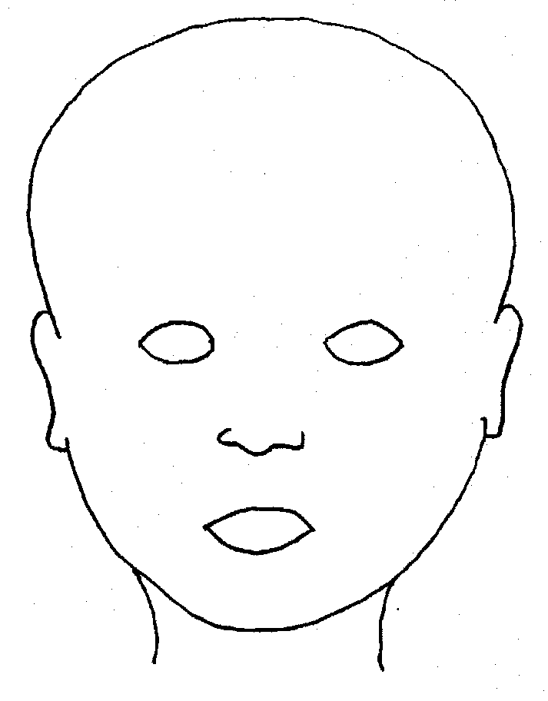 |  |  |  |  |  | 
FRONT |  |  |  |  |  | BACK
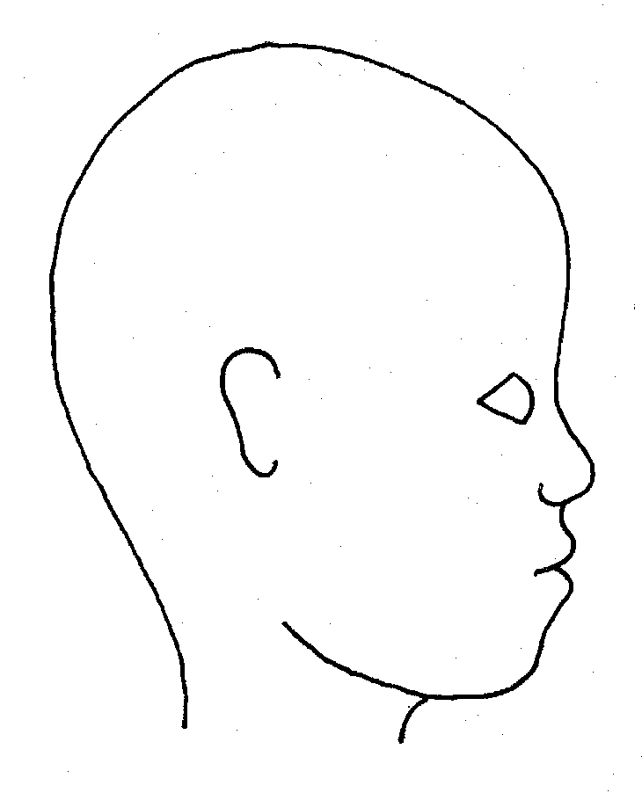 |  |  |  |  |  | 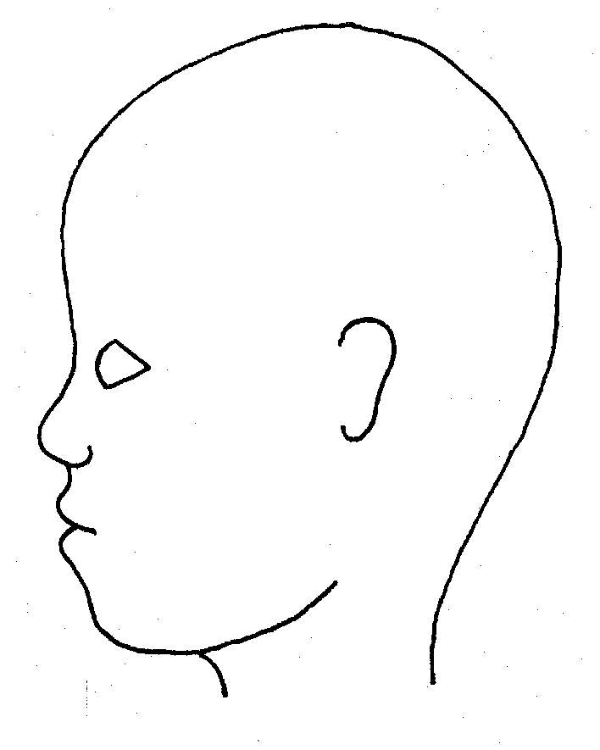
RIGHT |  |  |  |  |  | LEFT
Name of individual: |  |  |  |  |  |  |  |  |  | Date and time of observation:
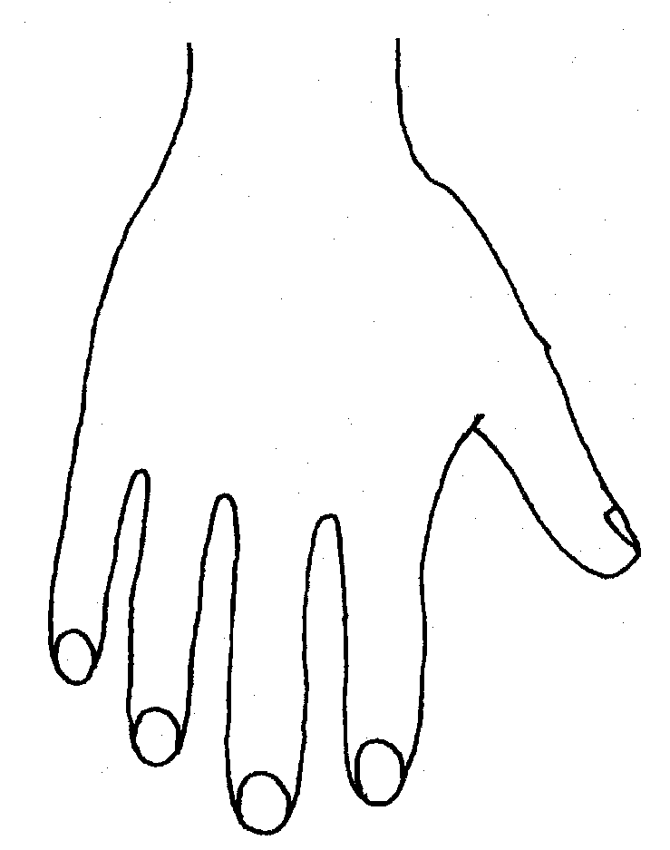 |  |  |  |  |  |  |  | 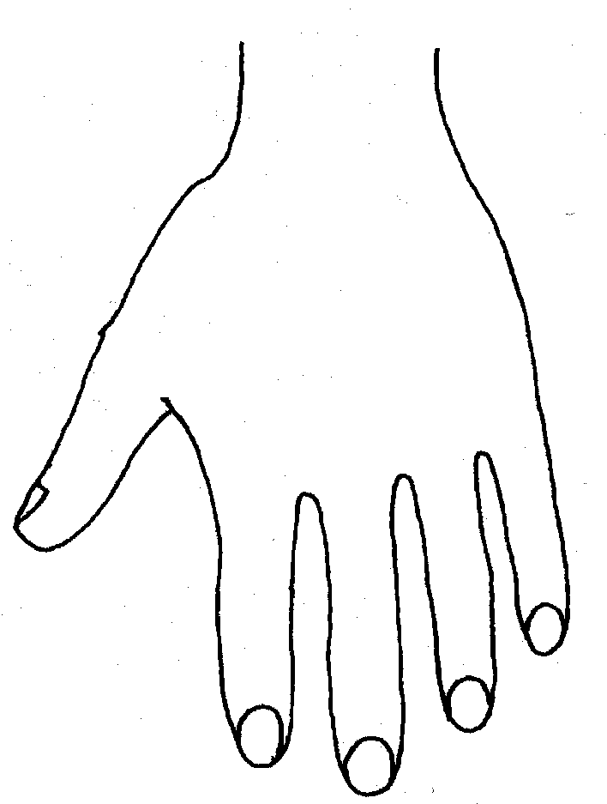
R |  |  |  |  |  |  |  | L
BACK
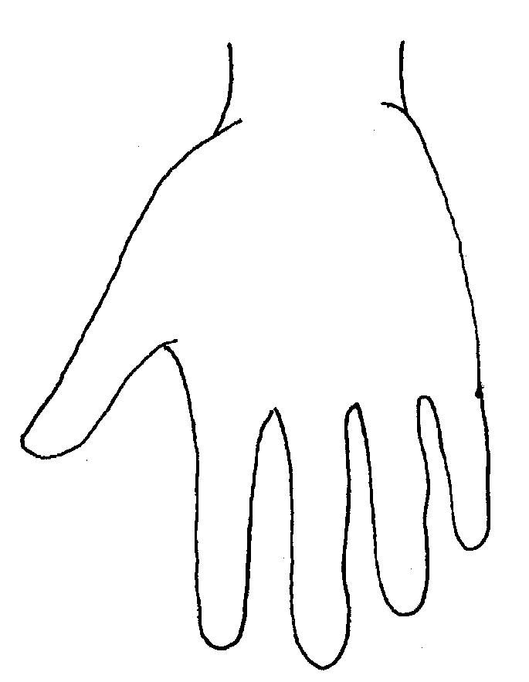 |  |  |  |  |  |  |  | 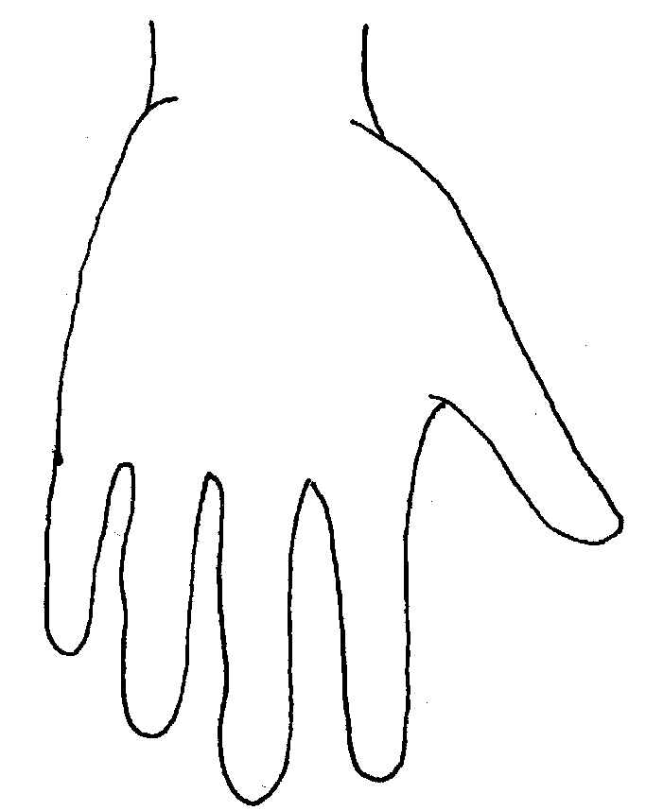
Name of Individual: |  |  |  |  |  |  |  |  |  | Date and time of observation:
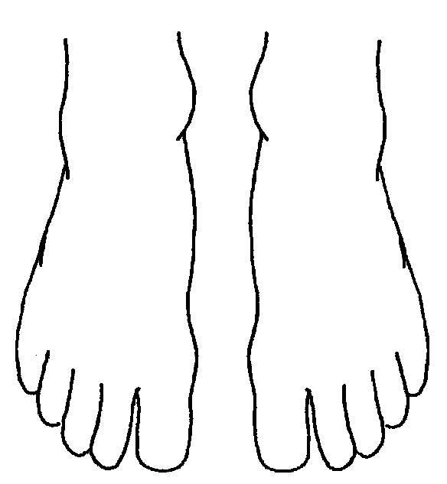 |  |  |  |  |  |  | 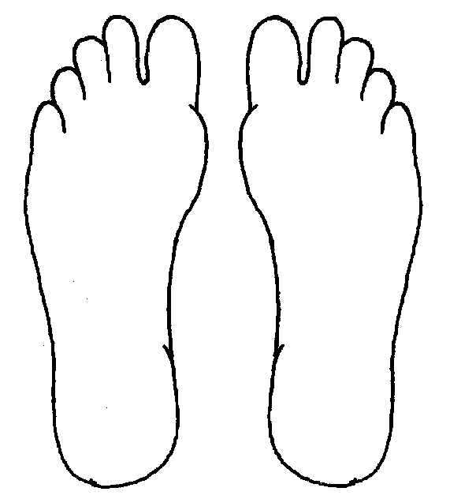
R | TOP |  |  |  | L |  | R |  |  |  | BOTTOM |  |  |  | L
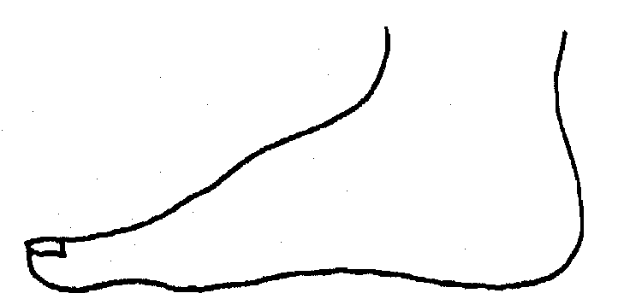 |  |  |  |  |  |  | 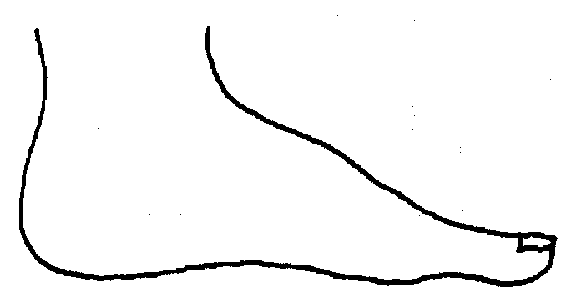
R |  |  |  |  |  |  | L
INNER
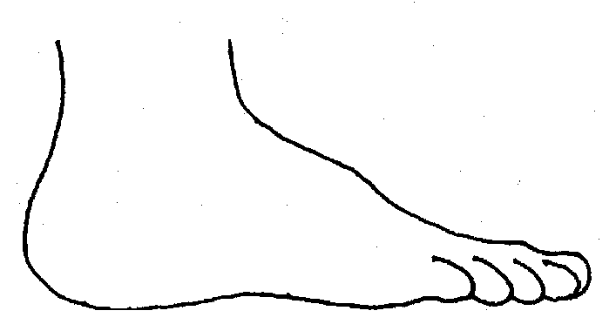 |  |  |  |  |  |  | 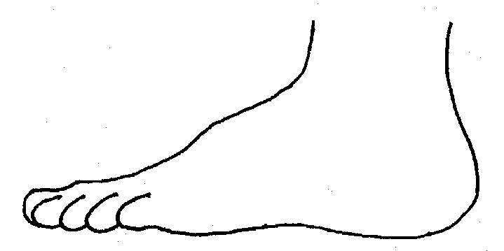
R |  |  |  |  |  |  | L
OUTER
Printed Name, Signature and Job title of staff:

EMMS INTERNATIONAL

Photograph Consent Form

I………………………………………………………..myself or the parent/guardian/carer of:

(full name)……………………………………………………………………..

(full name)……………………………………………………………………..

(full name)……………………………………………………………………..

hereby give EMMS International permission to use any still and/or moving image being video footage, photographs and/or frames and/or audio footage depicting the children or vulnerable adults named above,
taken by (name of photographer) …………………………………………………..

on behalf of EMMS International, on (date)………………………………………

at (place)………………………………………………………………………………
for any of the following uses:
• Advertisements, marketing, leaflets, or any other use such as for training, educational or publicity purposes.

The above consents will apply throughout the world and be for an indefinite
period / expire on (date).…………………………………….delete as appropriate

Signed………………………………………....Date…………………………………

Signed………………………………………....Date…………………………………

Address………………………………………………………………………………

………………………………………………………………………………………...

Postcode………………………………..
Organisation name: Event Location: Date:

Risk Assessment – Out of office promotional activities
Risk Assessment – Out of office promotional activities

PLEASE be clear that the person understands that they do not need to give consent
What are the hazards? | What might the issues be | Assessment Response  (Is there a risk? Yes, no or more detailed answer). | Do you need to do anything else to manage this risk? Consider the likelihood of harm occurring.  (Yes, no or more detailed answer). | Action by whom | Action by when | Done
Going back on consent
Contacts are not well enough | .
Contacts are vulnerable
Family member objects

Extortion
Violence
Travel challenges
Technical/equipment problems
Please review your risk assessment if it might no longer be valid, e.g. following an incident or if there are any significant changes to hazards such as new equipment or activities, or any new hazards.

These are the 9 protected characteristics in the UK’s Equality Act 2010.
National Guidance for Child Protection in Scotland. https://www.gov.scot/publications/national-guidance-child-protection-scotland/pages/3/
https://www.keepingchildrensafe.global/

